Yuri Lavinas 201820755

Assignment 2

Question 1

Interface I

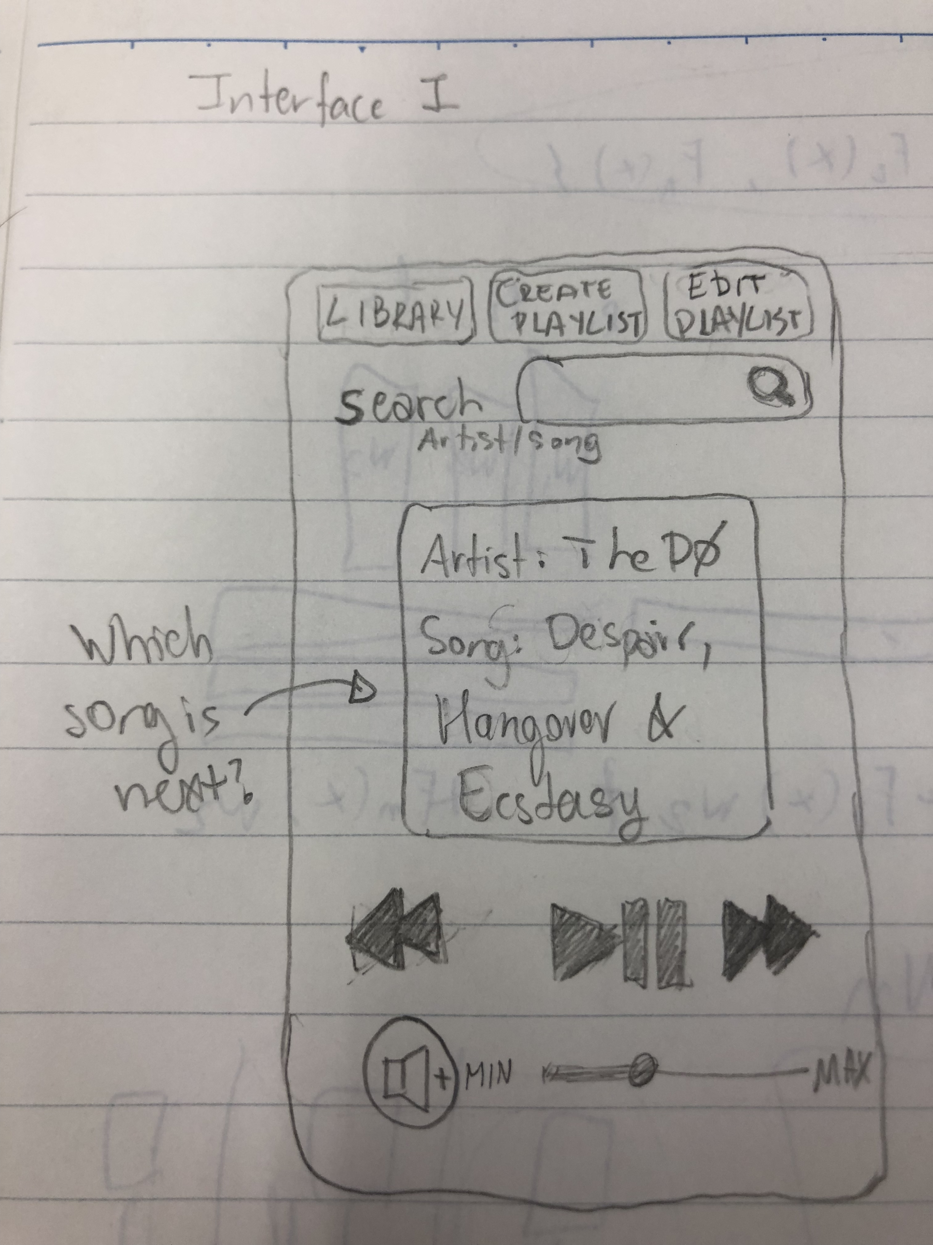

A user, when using the Interface I, may find some difficulties to learn about it, since each feature is designed in a different way. That said it is easy to find the main important features, once all of them are in the main screen. It lacks information about the next song that is going to be played as well as the songs that were already played.

It would be interesting to put together the buttons create playlist and edit playlist since both of them are about playlists in general. These buttons and the library button on the top make it difficult for the interface to scale in terms of number of features that could be added as buttons. While with just 3 elements it seems good enough, if more features are added then it may not be so clear where to find information. Also, the search engine searches for both artists and songs that simplify the general usage.

It is an interface that can be easily used with mouse and finger movements, but with the keyboard it may not be the case.

This interface may have not be suitable to add more features in terms of screen space, but since each feature is different from each other, besides the top buttons, to add another feature may not impact much on the interface.

Interface II

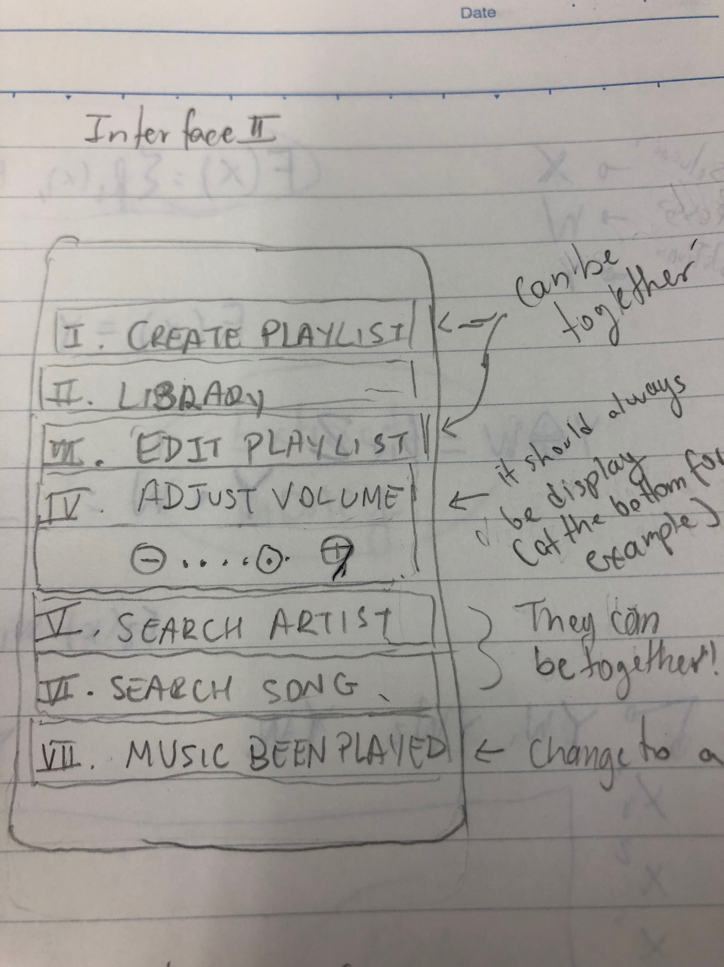

This interface, named interface II, is one that the user will find it easy to understand very fast, since all features are together and are shown in the same way. This list of features facilitates the user to know in advance where to look. On the other hand, if this list becomes too extensive, then the user will have difficulties to find specific features.

Here, there are two search buttons and they could be placed together. The adjust volume button should always be displayed (or at the top or at the bottom of the screen) as well as the create playlist and the edit playlist buttons could be integrated together.

To add new features is probably easy to do in this interface since all features are equal, but this also makes it hard to show which are more important.

For any music player interface, I think that the most important aspects of usability that matters the most in a music player are the song that is been played, the volume control and the play/pause button.

Question 2

Good example - thesaurus.com

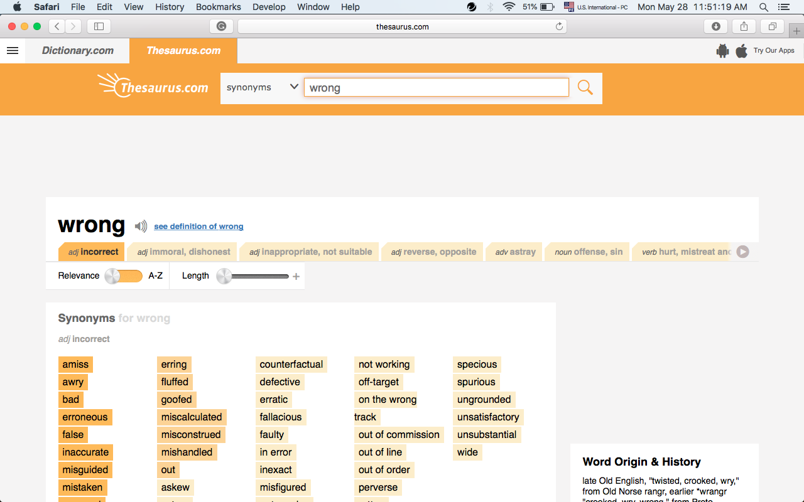

The users are people that want to find synonyms of a given word.

It is very easy to find where to search for the synonym, since the search feature is at the top of the website in a big white box that clearly contrasts with the orange label under it.

If you search for a word that is not found it shows others related to that, so that there is no need to come back to the previous page and search again. Since a word may have different synonyms depending on the meaning that the user is considering, the website shows some tabs that could be accessed be a simple click. The most common tab is the one that appears first. It is difficult to use the tabs, especially if you have to move on may of them. That said, some synonyms are shown at the tabs that facilitates the user interaction, by minimizing the number of interactions need.

Golden rules.

Strive for consistency - Most important features are displayed at the top while the less important ones, at the bottom. Also the position of features tends to be the same at every interaction.

Enable frequent users to use shortcuts - If there are shortcuts, they are not made clear.

Offer informative feedback - if a word searched is not found it tries to find the correct one. There are more information about the word than just synonyms, such as word origin and history.

Design dialog to yield closure - None presented.

Offer simple error handling - You can correct words than were not found and it shows possibilities.

Permit easy reversal of actions - It is possible to redo every step as well as easily starting again without having to move to the first page.

Support internal locus of control - It is very clear which word you are looking for.

Reduce short-term memory load - There are no much steps allowed and it is clear what have you done.

Bad example www.darebee.com

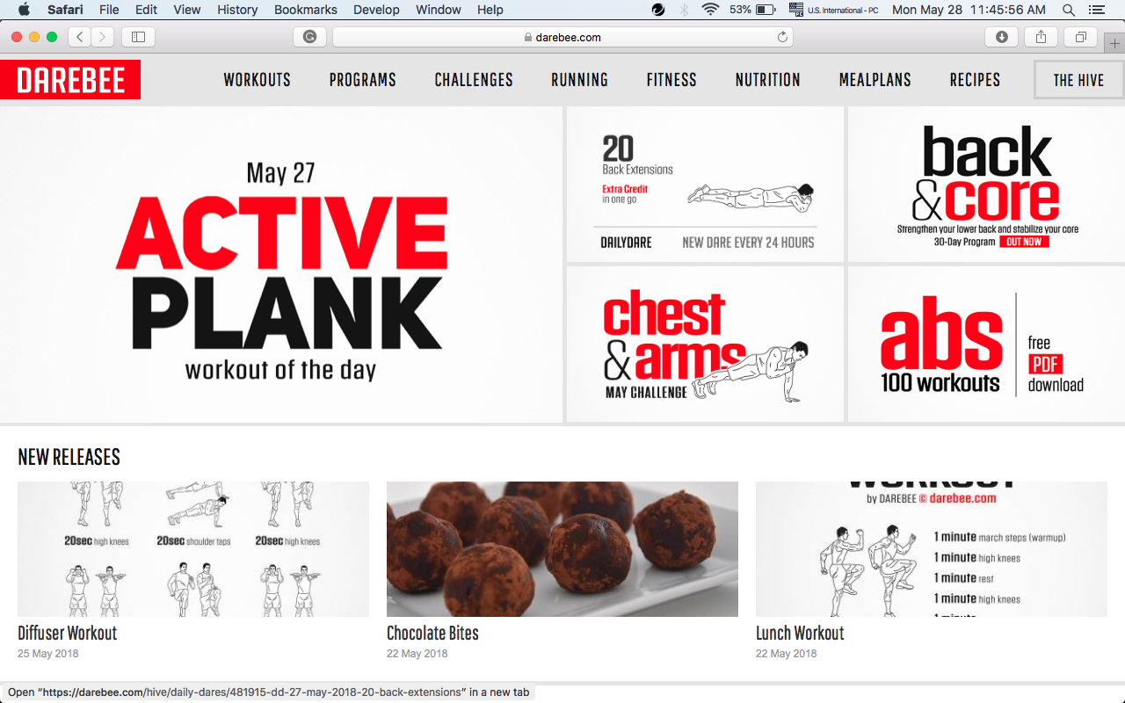

Golden rules.

Strive for consistency - Besides the top and bottom menu, the features position change at every interaction. They tend to be at the same position when considering the related steps of an interaction.

Enable frequent users to use shortcuts - If there are shortcuts, they are not made clear.

Offer informative feedback - The only feedback is the time ended beep.

Design dialog to yield closure - None presented, this is bad when using the timing feature.

Offer simple error handling - If a link is broken it goes to a technical page.

Permit easy reversal of actions - It is possible to redo every step, but sometimes it is hard to know the results of a reversal of an action.

Support internal locus of control - It is generally not very clear where you are and where to find the same information that the user found before.

Reduce short-term memory load - There are many steps allowed and it is not always clear what have you done. Information showed at a day is not always available on the next day.

I would change the layout of the website so that only the most important information are shown and the main page. The buttons at the top and at the bottom show different levels of interaction and information that makes it difficult to navigate among them.